

**EAST AFRICAN COMMUNITY**

**User Manual – Rapidly Deployable Experts (RDE) version 1**

**Prepared by**

**Ayub Manya**

**Table of Contents**

List of Figures 2

List of Tables 2

1 Introduction to the System for Rapidly Deployable Experts 3

1.1 Background 3

1.2 Features of The System 4

1.3 Actors in RDE 4

1.4 Getting Started with RDE 5

1.5 Logging in Or Signing Up in The RDE System 6

1.6 Updating User Profile of The Newly Registered Person 8

1.7 Menus and Navigation 9

2 System Admin

# List of Figures

Figure 1: Open RDE on a web browser 6

Figure 2: Log in to RDE Software 7

Figure 3: Signing Up in RDE To Create A User Account 8

Figure 4:updating user profile of the Newly Registered Person 9

*Figure 5: RDE Menu showing the various Apps* 10

# List of Tables

Table 1: The Features of The RDE System 4

# Introduction to the System for Rapidly Deployable Experts

## Background

The East African Community (EAC) is prone to public health emergencies such as outbreaks of contagious and life-threatening diseases (SARS, Ebola, COVID-19, etc), natural disasters (droughts, floods and chemical contamination of the environment), among others. In such emergencies, large numbers of people may require medical attention, overwhelming the health system. Considering the frequency and occurrence of disease outbreaks in the EAC region, there is a need to build the regional capacity to respond to outbreaks in line with the International Health Regulations (IHR 2005). It is against this background that the EAC Secretariat decided to establish an EAC Regional Pool of rapidly deployable Experts to respond to public health emergencies. This system has been developed to manage this pool of rapidly deployable experts.

The purpose of the system is to help the health management teams at the Regional level in making the right decisions on the deployment of experts during an outbreak. It utilizes the classical features of systems which comprise ***input*** *(*data entered by users*)***,** ***process*** (various analyses to be done in the systems) and***output (***different reports and information that can be generated).

1. **Input:** The system provides a user-friendly interface for users to enter data. The screens for data are easy to follow. Regarding inputs, the prospective experts enter their data during the application to join the pool, deployment and Post-Deployment Phase.
2. **Processes:** The system automatically computes names, telephone numbers and qualifications to come up with qualified persons depending on set conditions. The system also checks the validity of the data to make sure the data entered reflects the reality on the ground. Utilizing the analysis of the data, system administrators recruit and deploy the experts accordingly. The experts may be sought from within the country of the emergency, the region or the continent and will be deployed according to their competencies for emergencies at hand. Other selection criteria may include the “One Health” approach that promotes the attainment of optimal health for people, animals and the environment.
3. **Output:** Provide different tools for reporting – both for automated routine reports and analysis reports, and in addition provides the user with functionality and flexibility to make their user-defined reports. Examples of outputs include a list of all experts in the pool and their qualifications, those pending deployment, and those who completed deployment. Other outputs include copies of CVs and even deployment reports.

## Features of The System

Table 1 shows the features of the system

| **Feature** | **Particulars** |
| --- | --- |
| User Management | RDE allows self-registration. Once staff has been registered, an account is created for them and a confirmation email sent to them for subsequent self-management of information in their profile |
| Open Source Platform | RDE is designed on an open-source platform, with no recurring licensing fee, which makes the solution sustainable in the long term |
| Interoperable | RDE is built with the Fast Healthcare Interoperability Resources (FHIR) standard that allows for sharing of data between itself and other systems through APIs |
| System Validation | The system is built with data entry validation to ensure the completion, validity and integrity of data |
| System and Data Security | In addition to restricted user accounts that allow users to enter or view specific datasets, data in RDE is encrypted to ensure the privacy and confidentiality of human resource data |
| Real-time reports | RDE is built with real-time reports and summaries to facilitate decision making |

***Table 1: The Features of The RDE System***

## Actors in RDE

In principle, the system is divided into two main sections; one section addresses the experts and the other deals with system administration including approvals and deployments. Both sections are controlled by the use of appropriate administrative rights.

The **Rapidly Deployable Experts:**

* Apply to be included in the regional pool
* Track the application process and deployment
* View the deployment requests/notifications
* Accept or decline deployment requests
* View/Update their profiles
* Submit mission reports and feedback

The **EAC level Users:**

* Review and approve the expert enrolment applications
* View submitted mission reports from the experts

**Partner State Level Users**:

* View applicants from their states and make any recommendations
* View the reports of the deployed pool

the **EAC level Content/ICT manager**

* Add/manage application contents like qualifications, competencies, New Partner states,
* Configure the system metadata (e.g. specializations) and workflows
* Server management

## Rapidly Deployable Expert (RDE)

1. **Getting Started**

The RDE software is a web-based application and can be accessed through a **web browser** (*an application you use to access the internet e.g. Internet Explorer, Mozilla Firefox, Google Chrome, Opera, etc.*) when you have an Internet connection. Some aspects of the system are multi-language enabled and can allow change of language (English, French and Swahili).

At the moment, we have not identified the best browser, so all browsers are equal. The following are the steps for opening the RDE.

**Step 1**: Open your web browser

**Step 2**: In the address field type in the URL <http://196.41.38.246/> and the RDE login screen will appear.



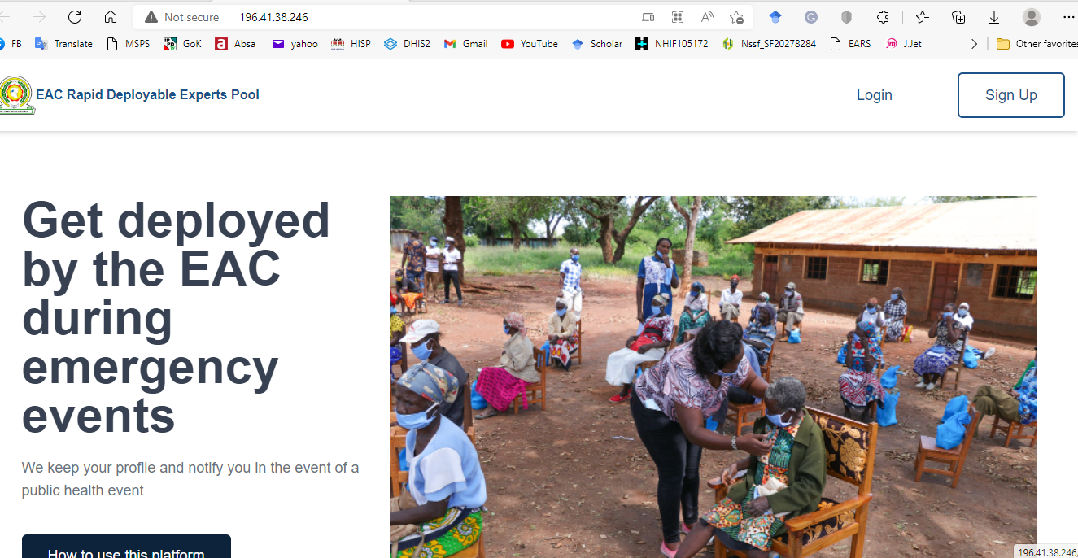

***Figure 1: Open RDE on a web browser***

## Logging in Or Signing Up in The RDE System

The home page has two options, sign in and sign up. If you already have login credentials, then you just enter your username and password to login into the application. In case the login is not successful, you will be notified immediately that the username or password provided is incorrect and will be asked to re-enter credentials. Once you have successfully logged in, you will see the RDE Dashboard where you can immediately monitor the latest data in your selected charts, tables, maps etc. Use the logout link in the upper right corner - where you have the initials of your user name to log out of the system.

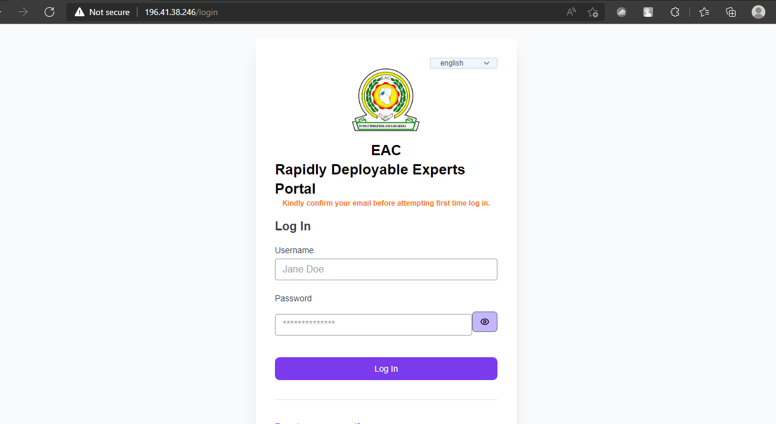

***Figure 2: Log in to RDE Software***

Those who do not have user rights, need to sign up in the system to create their user accounts. The person will follow the prompts and fill them accordingly. Once the user account is created, the system will send an email to the person for the activation of the account. After the email verification, the newly signed-up person will be able to log in using the credentials provided during the sign-up. During the first login, the person will be required to create his/he profile that includes personal information and qualifications to enable the activation of the account.

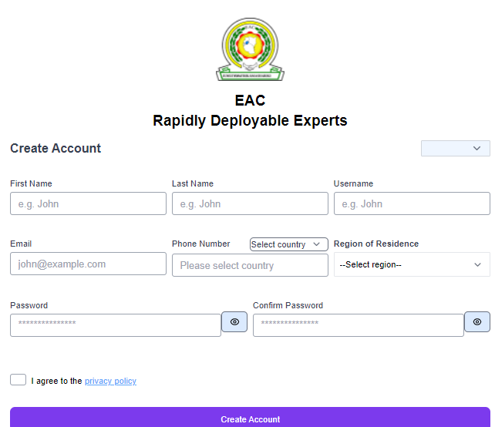

***Figure 3: Signing Up in RDE To Create A User Account***

## Updating User Profile of The Newly Registered Person

After the email verification, the newly signed-up person will be able to log in using the credentials provided during the sign-up. During the first login, the person will be required to create his/her profile that includes personal information and qualifications by clicking the ‘Create’ Profile button.

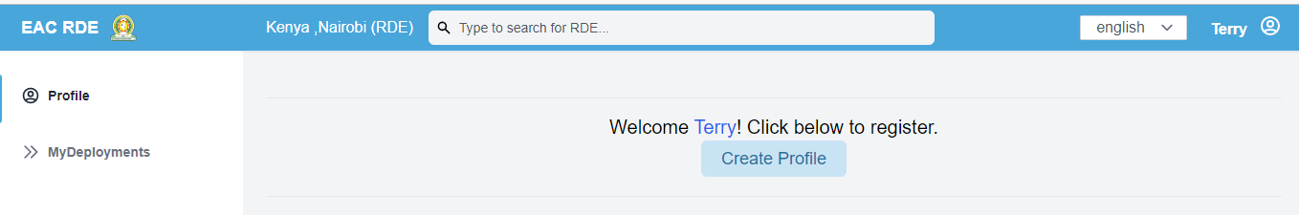

***Figure 5: RDE landing page***

A registration form appears that the expert can use to update their profile by providing more information. The data provided during sign-up will be pre-filled in this form. The user can update if necessary.

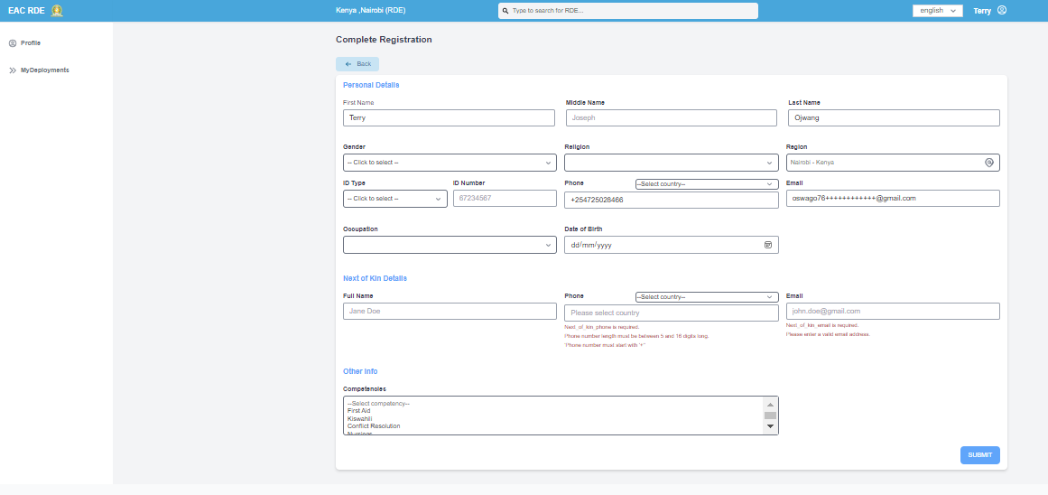

***Figure 6:updating the user profile of the Newly Registered Person***

After filling and submitting the registration form, the user will be redirected to the profile page where they can view, update and add extra information such as qualifications, references, and experience and cv. At this stage, their profile status will show ‘Pending Approval’. Any recommendations made on their profile by a system admin will appear in the recommendations tab. The user can deactivate their account by clicking on the ‘Deactivate Account’ button so as not to be considered for approval or deployments.

1. **User email notifications**

A notification message will be sent to the attached expert/RDE profile email when:

1. An admin makes a recommendation on the profile
2. A deployment request is sent to their profile
3. The user signs up for the first time.
4. User tries to reset password
5. **RDE Deployments**

Once approved by an admin, a deployment request may be sent to an expert’s account for a particular public health outbreak. The expert can access this information by going to the ‘MyDeployments’ section of their profile. At this point, they can choose to either accept or reject the deployment request. If the deployment request is accepted, the expert will be contacted by an EAC admin for pre-deployment activities and procedures.

1. **System Admin**
   1. Menus and Navigation

The RDE consists of various modules (major components) each of which has specific features, such as updating and creation of a new entity). These modules are on the left side. To move to a new module, you need to click on the module you want to open.The following are the menus.

* **Active deployments:** Here you can view all the active deployments
* **Public Health Events** allow one to review the defined public health events or outbreaks. Provides the option to add more public health events
* **Admin Reports:** Under this menu,you can access the various reports in the EAC or add more reports. This acts as a repository of various reports, not necessarily related to the outbreak at hand
* **Partner States:** This provides the list of EAC partner states with their various districts/counties/provinces. An admin can add/update the partner states/districts/counties/provinces.
* **Competence:** This provides a list of all the competencies that one can choose from. It allows one to add the competencies.
* **Occupations:** This provides a list of occupations listed in the system. It provides an opportunity to create new ones or update existing sones
* One Health Sectors: This takes care of the one health approach in the management of emergencies.
* Academic Qualification Levels: This provides a list of academic qualifications including the bachelor's or master's degrees
* Public Health Event Types: This shows whether it is public health event or a natural disaster

Figure 5 shows the screenshot of the various menus in the system

1. **Login**

The admin login page can be accessed via the url : <http://196.41.38.246/login>. A login form appears as shown in the screenshot below



***Figure 7:admin login page***

1. **Home**

Upon successfully logging in, the admin will be redirected to the homepage as shown in the screenshot below. The homepage has a dashboard that shows the brief stats about the RDE pool such as the total number of experts in the pool, total number of actively deployed experts, total number of public health events defined in the system and total number of partner states.

The list of all RDEs present in the system is also shown in the homepage for the admin account. This pool has can be filtered by the admin.

The homepage also includes a filter window that contains a list of grouped filter parameters such as partner state, gender and academic degree. These filters can be used to filter the existing RDE pool for various reasons as defined by the EAC. To filter the default list, an admin can select the desired filter parameters then click on the ‘Filter’ button.

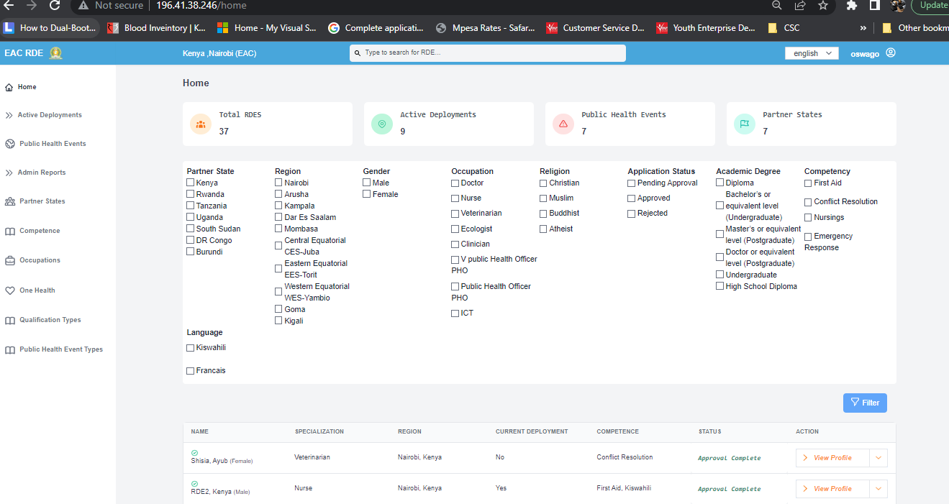

***Figure 8: Admin home page***

1. **Active Deployments**

This route/module contains a list of profiles for all the experts that are currently deployed in various areas for various public health events using the system. The admin can use this page to quickly see who is deployed where.

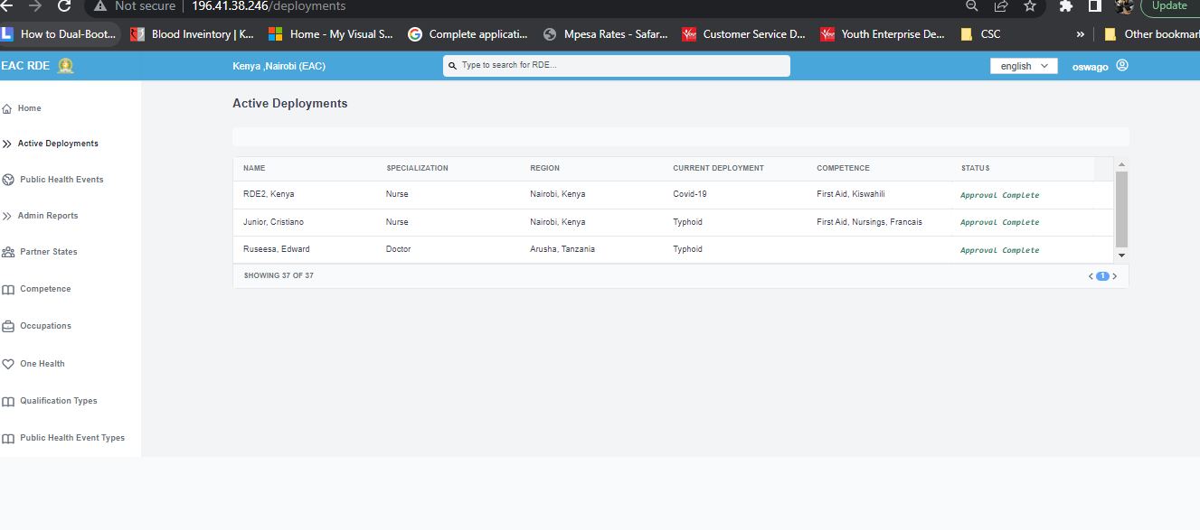

***Figure 9: Active deployments***

1. **Public Health Events**

This route/module contains a list of all the public health events defined in the system. The admin can use this route to

i) add a new public health event,

ii)view deployments per event,

iii)view suggested experts and create a filter for a specific event,

iv) add report for the event

iv) update event information

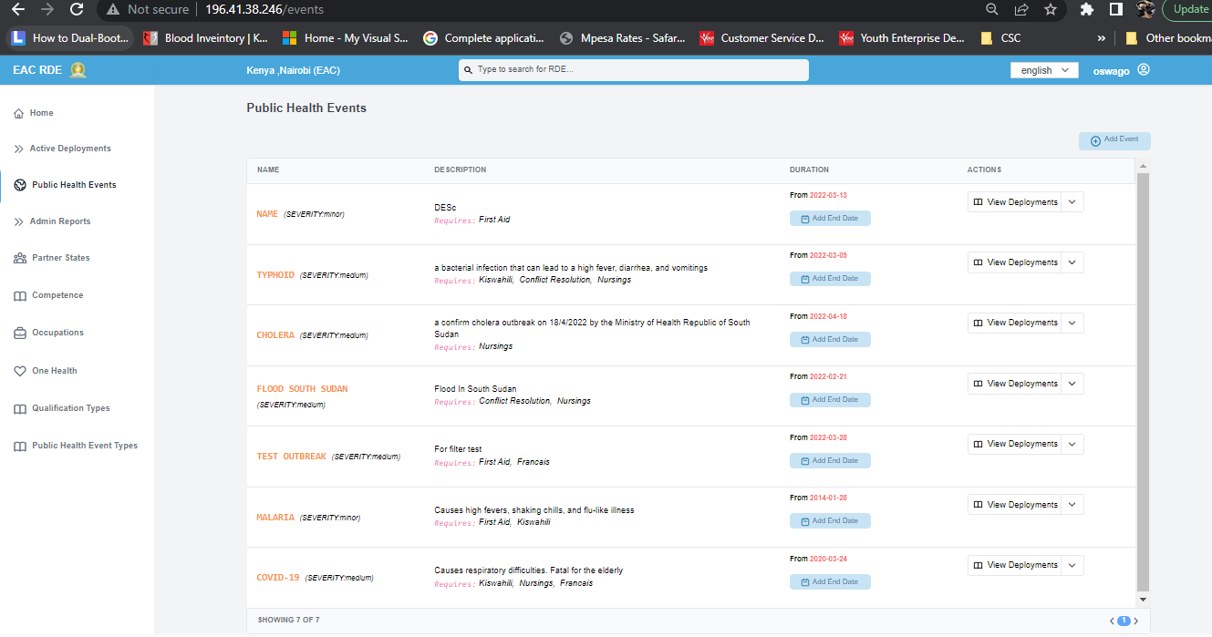

***Figure 10: Public Health Events***

1. **Admin Reports**

The admin can use this route/module to upload any reports/files that are not necessarily related to any outbreak/event

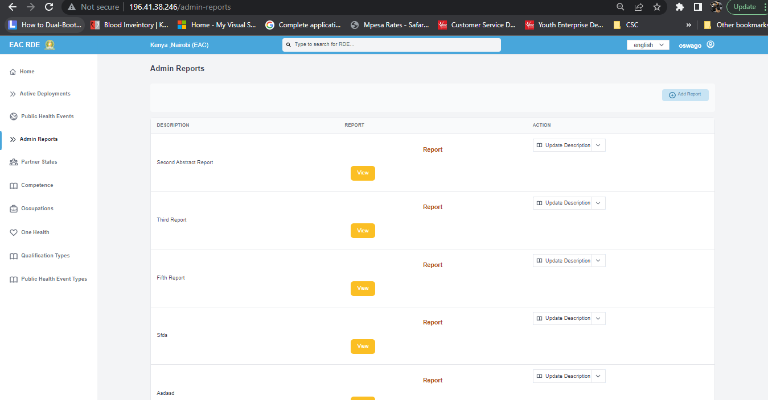

***Figure 11: Admin Reports***

1. **Partner States**

The admin uses this route/module to manage partner state information on the platform. He/she can add/update partner state information, add/view/update counties/districts. They can also see brief stats about experts per partner state such as total RDES, number of RDEs pending approval and those currently deployed per partner state.

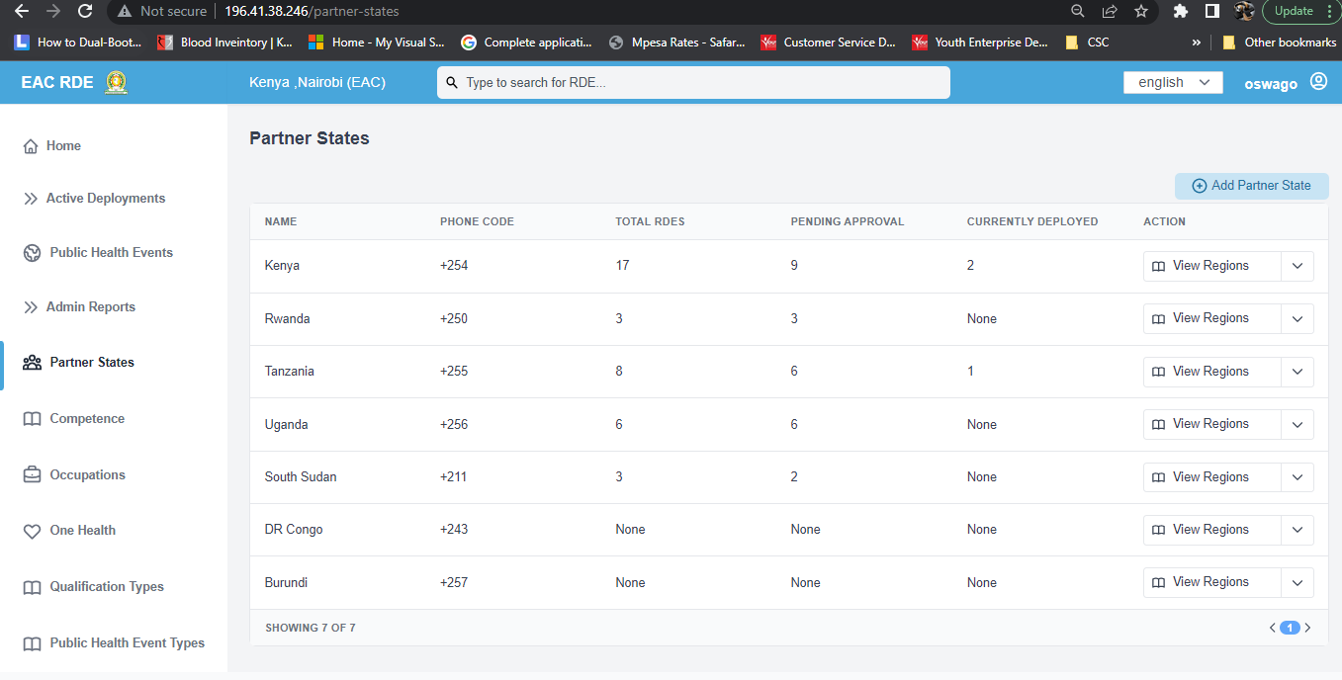

***Figure 12: Partner States***

1. **Competence**

This route is used for managing competences in the pool and contains actions such as creating and updating a competence. The competences are grouped by type i.e. work and language competences.

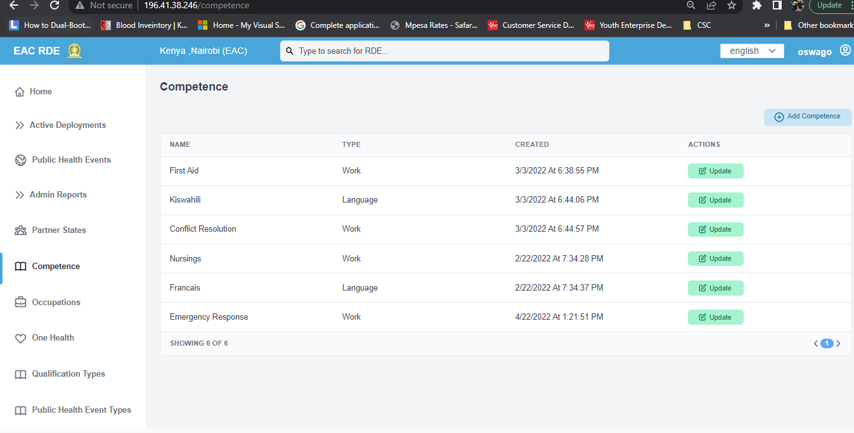

***Figure 13: Competence***

1. **Occupations**

This route is used for managing occupations in the pool and contains actions such as creating and updating an occupation. The occupations are grouped by one health sector such as Human Health and Animal Health.

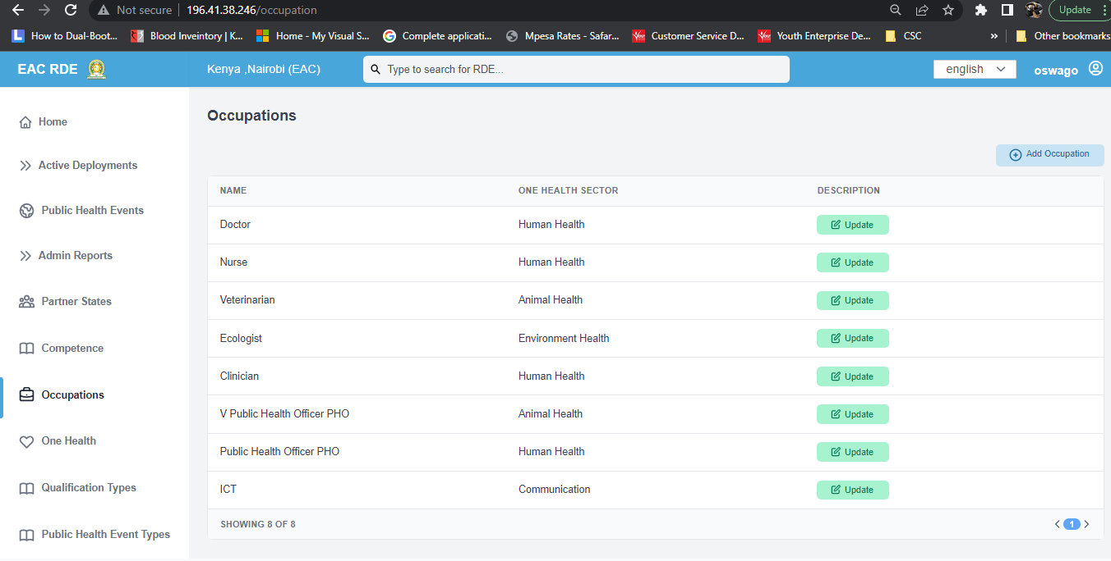

***Figure 14: Occupations***

1. **One Health**

This route is used for managing one health sectors in the pool and contains actions such as creating and updating a one health sector

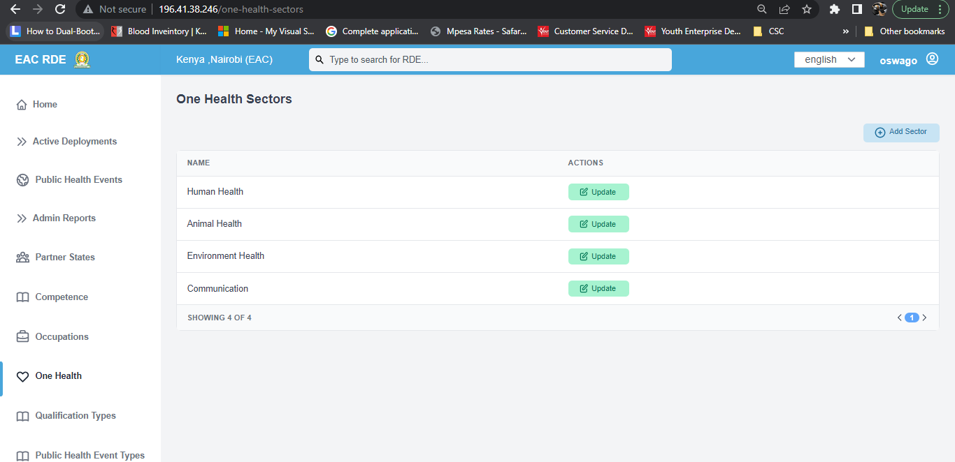

***Figure 15: Occupations***

1. **Qualification Types**

This route is used for managing qualification types in the pool and contains actions such as creating and updating a qualification type.

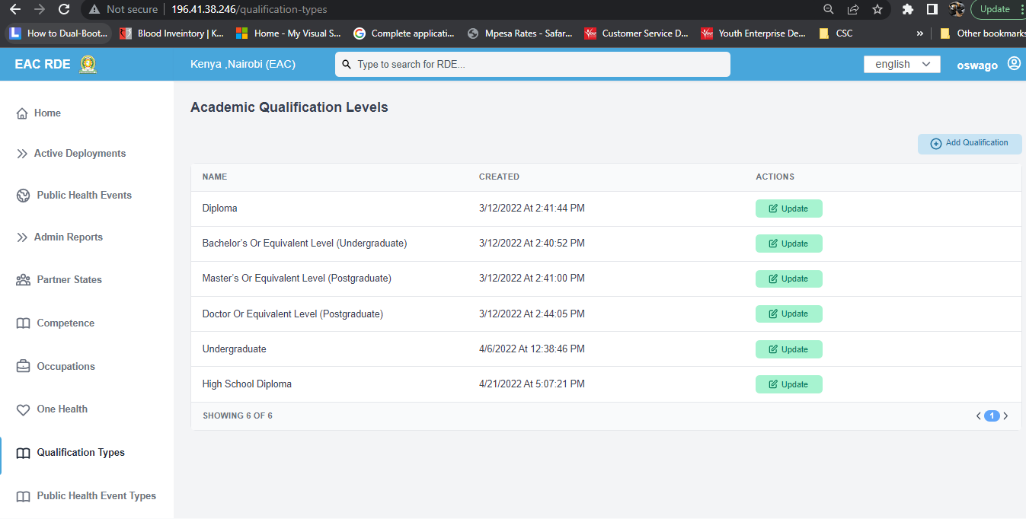

***Figure 16: Qualification Types***

1. **Public Health Event Types**

This route is used for managing public health event types in the pool and contains actions such as creating and updating a public health event type.

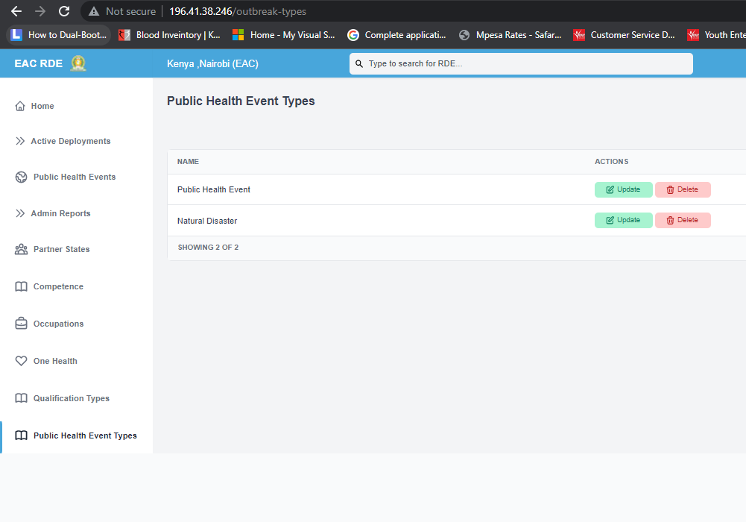

***Figure 17: Public Health Event Types***

**Filter**

The filter contains a number of filter parameters that can be used by the admin to narrow down the list of experts that they’re looking for in the pool.

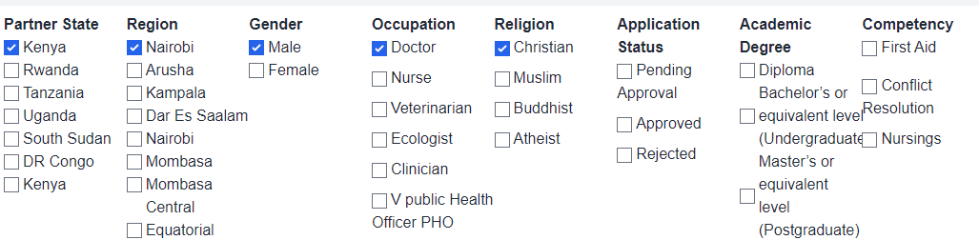

**Search and Language Filter**

The admin has a search field which can be used to quickly find experts in the pool. The search is done by typing the name as the search parameter. Both the admin and the expert account also have a language switcher located on the top right of the platform which allows them to switch between English, French and Swahili as desired languages. Notably, the language switcher only translates the labels and not the data submitted by the user. Both the filter and language switcher are shown in the screenshot below.



Drafted by the IT Consultants.

22/4/2022